Appendix A. OPWL Portfolio Worksheets for a Systematic Multiple Studies Review and eLearning Course as an Intervention Development
Table 1. OPWL Learning Goals
Master’s degree program learning goals | Demonstrated in this case? | Explanation
- Conduct the performance improvement process in a way that is systematic. | X | - The performance that my work attempts to improve upon is the development and execution of a student support program (The Boise State University College of Engineering Stellar Engineering Students Graduate Program Scholarship, aka SENS-GPS) to increase the retention and persistence of low-income, first generation, and underrepresented graduate students in engineering programs.  - To this end, I conducted a systematic multiple studies review (MSR) process.  - My process was systematic in that it was stepped, documented, and replicable.  - I followed guidelines from industry experts (Hong et al., 2018; Petticrew & Roberts, 2006; Pluye, et al., 2009) to search for resources and then appraise the quality of those sources using a systematic scoring model, the Mixed Methods Appraisal Tool (MMAT) (Hong et al., 2018).
2. Conduct the performance improvement process in a way that is systemic. | X | - My study was systemic in nature as the intervention programs researched spanned many areas of the university system including academics, social structures, financial supports, peer relationships, and faculty involvement.  - The ISPI standards and Tinto’s (2012) Conditions encouraged me to think systemically about the problem and see how each support or program element was influenced by others. This led to the creation of a unique model (Pearson, et al., 2020) that aligned Tinto’s (2012) Four Conditions and data sets from an existing successful program into one graphic representation of the systemic nature of intervention programs.
3. Conduct the performance improvement process in a way that is consistent with established professional ethics. | X | - Our work carefully followed the following principles as outlined in the ISPI Code of Ethics:  - The Add Value Principle  - The Validated Practice Principle  - While our research questions changed as the project progressed based on the results we were finding, I always kept in mind our goal – create a product that can inform the design of the SENS-GPS intervention program. The grant that funded my role was directly tied to the value I could add to the program, so it was imperative for future funding that I was able to succeed in adding value.  - A Systematic Multiple Studies Review is itself a validated practice supported by evidence from Hong et al., 2018; Petticrew & Roberts, 2006, and Pluye, et al., 2009. Additionally, the research that conducted was limited only to peer-reviewed journal articles that reported empirical findings.
4. Conduct the performance improvement process in a way that is consistent with established professional standards. | X | - The project was fully guided by multiple ISPI standards including:  - Focus on results: work informed the design of an intervention program put in place to achieve measurable positive outcomes for the university and student participants.  - Take a systemic view: one of the outcomes of the project was the development of a Venn diagram that illustrates the relationships between intervention systems and components.  - Add value: the literature review was focused on finding data and evidence to provide the greatest impact to student participants and continue the work of the grant team.  - Work in partnership with stakeholders: My work was done for a project team in collaboration with my advisor. Their needs drove my research, and my research will inform their future work.
5. Align performance improvement solutions with strategic organizational goals. | X | - The Boise State University College of Engineering describes themselves as “excelling through diversity and inclusion” (Boise State University College of Engineering, 2020). This project will directly impact the diversity and inclusion of the student body by increasing the persistence and retention of underrepresented students.  - The goal of the SENS-GPS is to increase the persistence and retention of graduate-level engineering students.  - The solution I developed includes a complete literature review of 31 empirical studies conducted on similar programs as well as a model of student support. The university can use these findings and tool to help guide the future development and implementation of their program.
6. Make recommendations that are designed to produce valued results. | X | - My research found myriad sources that discuss the necessity of expanding both the sheer size of our STEM workforce as well as the diversity of minds within that workforce (National Academies of Science, Engineering, and Medicine, 2019; Institute of Medicine, 2011).  - Critical to expanding that workforce is to provide opportunity and support to students who in the past may not have been able to consider pursuing STEM careers, such as students whose parents didn’t go to college (first generation or FG), those from low-income families (LI), or those who are simply underrepresented in the field (UR).  - The Boise State SENS-GPS was put in place to help increase the number of skilled and diverse minds entering the engineering workforce in future years, specifically from FG, LI, and UR populations. The literature review directly supports those efforts by offering guidance to the program team as they continue to develop and expand upon the program, as well as providing them with a roadmap to help with their ongoing assessment of the program.
7. Collaborate effectively with others, in person and virtually. | X | - The literature review was conducted in collaboration with Dr. Lisa Giacumo, my graduate research advisor.  - Dr. Giacumo guided me through the process of conducting a systematic multiple studies review, something that was completely new to me.  - We met weekly to discuss my work and review the content I had developed. Dr. Giacumo gave me feedback both on process and on content, while at the same time being very open and willing to consider my perspectives and input.  - Dr. Giacumo also served as the bridge between the work I was doing and the panel who sponsored the SENS-GPS program.  - All work was conducted virtually and while that was slightly challenging at first, we developed a rhythm and cadence to our work that allowed us to collaborate easily within the same documents.  - While the development of the paper was somewhat iterative in nature, with multiple revisions occurring over a 5-month period, we were still able to complete the paper and submit it for publication shortly after the end of my graduate assistantship.  - The resulting paper was reviewed and approved by the SENS-GPS panel, and it’s currently being considered for publication which indicates a successful collaborative outcome
8. Communicate effectively in written, verbal, and visual forms. | X | - It’s clear that the communication between myself, Dr. Giacumo, and the project stakeholders was effective as it resulted in a 42-page literature review that is currently being considered for publication.  - Through effective communication with my advisor Dr. Giacumo, I was able to conduct the required research and develop a solid product to present to both the Boise State SENS-GPS panel, as well as the National Science Foundation who awarded the Boise State College of Engineering the grant to fund the work.  - Since this research process was completely new to me, there was a learning curve in regard to interpreting expectations and deliverables. Though clear and frequent communication, in which I reached out to Dr. G whenever needed outside of our standing weekly meetings to ask specific questions, I was able to complete the process with minimal rework and on time.
9. Use evidence-based practices. | X | - The systematic multiple studies review (MSR) is a process grounded in ample evidence (Hong et al., 2018; Petticrew & Roberts, 2006; Pluye et al., 2009).  - Our research relied only on peer-reviewed academic journals as sources.  - A MSR is a particularly appropriate process for this work because it can be replicated, and it integrates all methods of research that are returned by the search: quantitative, qualitative, and mixed-method.  - As explained by Nuriun and Yeaton (1987) as cited in Pluye et al. (2009) ‘‘The richest and most reliable summarizations of ‘what we know’ in a given area can best be achieved through an alliance between qualitative and quantitative information and methods of investigation’’ (p. 707).
10. Contribute to the professional community of practice. | X | - The literature review I completed is currently under consideration for publication with an academic peer-reviewed journal.  - Should we be chosen for publication, the findings from my research will help guide institutions as they develop intervention programs aimed to increase the persistence and retention of FG, LI, and UR students in STEM fields.  - I created “new knowledge” through the development of visual model that brings together my findings in an easy to digest format.  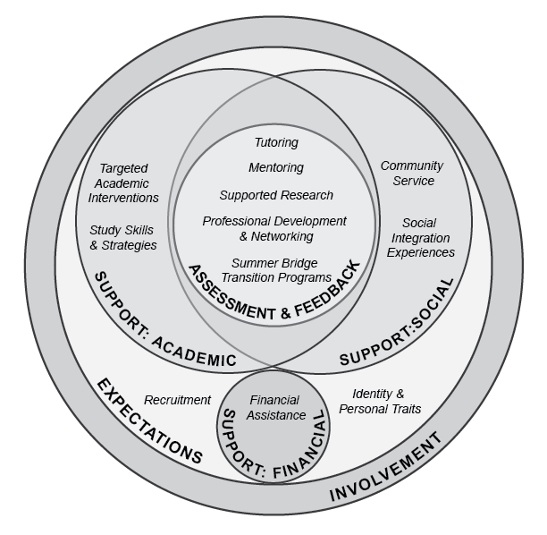  - It is also my hope that the paper will shine a light on the need for more programs such as the SENS-GPS at Boise State, as well as the need for additional empirical research on program specifically developed for graduate students, an area currently lacking in data.

Table 2. OPWL Tools/Phases

 | Section 2 – HPT Phase  Section 1 – OPWL Tool | Performance Analysis of Need or Opportunity | Intervention Selection, Des.& Dev. | Intervention Implem. & Maintenance | Evaluation | Change Mgmnt
 | - Gilbert's first, second and third leisurely theorems
 | - Rummler's and Brache's performance matrix
 | - Langdon's language of work (LOW)
 | - Mager's and Pipe's performance analysis flowchart
 | - Kaufman's organizational elements model (OEM)
 | - Marker's synchronized analysis model (SAM)
 | - Kellogg’s program logic model
 | - Brinkerhoff’s success case method (or only training impact model)
 | - Chyung’s 10-step evaluation procedure
 | - Kirkpatrick’s 4-level model of evaluation
 | - American Evaluation Association (AEA)’s guiding principles for evaluators
 | - ISPI’s code of ethics |  | X
 | - ISPI’s standards for performance improvement |  | X
 | - Thorndike's Law of Identical Elements
 | - Principles of Reinforcement from radical behaviorism
 | - Cognitive Information Processing Model (computer analogy)
 | - Knowles' Core Adult Learning Principles
 | - Bloom’s taxonomy of educational objectives
 | - Mager’s 3-part method for writing instructional objectives
 | - Keller’s ARCS model for motivational design of instruction
 | - Harless’ 13 “smart” questions
 | - Procedural analysis, learning hierarchy analysis or other established task analysis method
 | - Bronco ID model or another established ID model
 | - Merrill’s first principles
 | - Gagne’s 9 events of instruction
 | - Authentic learning assessment
 | - Broad & Newstrom’s strategies to promote transfer of learning
 | - Business Logic Model of Silber and Kearny
 | - Marker’s Six-P Framework for Evaluation
 | - Five Stage Change/Implementation model (Based on Rogers and Kotter)
 | - SWOT Analysis
 | - Force-Field Analysis
 | - Double-Loop Feedback
 | - Cognitive load theory (CLT) |  | X
 | - Cognitive theory of multimedia learning principles |  | X
 | - Other – Describe an established tool that is not listed in this matrix: |  | X  Mixed Methods Appraisal Tool (MMAT)

